**Monday, June 16, 2025**   
FOR IMMEDIATE RELEASE  
  
**Level Up Your Summer at the Ellsworth Public Library  
Library Releases Its Summer Reading Program 2025 for All Ages**   
  
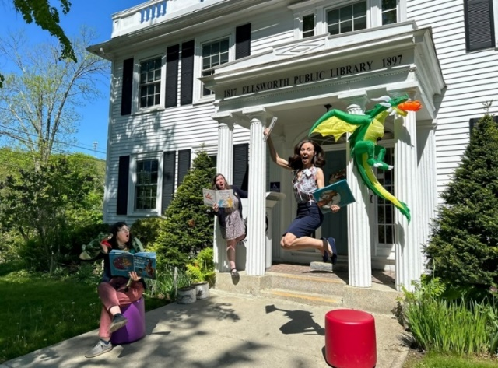   
EPL 2025 Summer Reading Theme: Level Up Your Summer (photo: courtesy of EPL)  
  
Ellsworth, Maine – From puppets to pollinators, and Jane Austen to jump ropes, the Ellsworth Public Library’s 2025 Summer Program promises memorable experiences and meaningful connections every Monday through Saturday. Residents and visitors of all ages are invited to level up their summer at their local community hub between July 7 and August 21. This season of free public programming is one of the library’s most dynamic and collaborative to date—designed to spark curiosity, foster creativity, and deepen connections with the local environment.   
  
Summer Reading 2025 is anchored by two weekly evening performance series—Wednesday Night Family Performances and Thursday Night Events for Adults, both beginning at 6 PM—alongside dozens of interactive workshops, outdoor adventures, and hands-on creative experiences.

“At its core, this summer is about growth and connection,” said Communications Director Berit Becker. “Whether it’s through reading programs, enjoying or learning music, exploring science and nature, engaging in artistic, playful, or culinary experiences, or being amazed by magic, the library is offering a safe space for everyone to explore and expand.”  
  
Visit [www.ellsworthlibrary.net](http://www.ellsworthlibrary.net/) for the full calendar and event registration details. The library will be open until 7 PM on Wednesday nights during the summer months.

**Kick-Off: A Summer of Story, Adventure, and Imagination**

The season begins on Saturday, June 21 with a Kick-Off Party from 10 AM to 12 PM, themed *Level Up Your Story*. Featuring lawn games, an outdoor scavenger hunt, and the launch of the library’s Reading Dragon character design contest, the event sets the tone for a summer full of wonder and possibility.   
  
Participants are encouraged to dream big and imagine themselves as the heroes of their own adventures—alongside original creature companions they can design and submit for a community vote. The winning design will be featured in the **October edition of Reading Dragons**; a program launched in 2024 to promote daily reading and enhance literacy across the community.

**Family Favorites: Wednesday Night Performances**

Families can look forward to weekly Wednesday night performances at 6 PM, which bring magicians, puppeteers, artistic performances, and animal educators to the library lawn or main floor. Here are the dates:

* *Norman Ng Magic Show* (July 9)
* *The Silver Circus with Andrew Silver* (July 16), plus a   
  Clowning Workshop with Andrew Silver earlier that day (at 4:30 PM, Ages 5 +)
* *Magician Peter Boie (July 23)*
* *Mr. Drew and His Animals Too* (July 30)
* *Frogtown Mountain Puppeteers' “Everybody Loves Pirates”* (August 6)
* *Wes Booth: Reading is Magic (August 13)*
* *Showtime Steve Variety Show* (August 20)

Complementing the performances are special workshops like “Out on the Lawn – A Tie-Dye Workshop” with OUT Maine (July 9 at 2 PM), Eco Heroes: Upcycling with Marti Dayton (July 11, 18, and 25 at 2 PM, ages 5 -12), Ukulele Camp with Ms. Jean on Monday afternoons at 3 PM (ages 8-12), and the Junior Dog Trainers series with Salty Dogs Obedience (July 10, 17, 24, 31 at 3 PM, ages 6 – 12).

Nature lovers can register for Riverside Family Scientists (Tuesdays at 1 PM, July 8–August 12 at 1 PM), a series exploring local ecosystems in partnership with Maine Outdoor School, Frenchman Bay Conservancy, and Woodlawn Museum. Monthly Outdoor Adventure Storytimes in collaboration with Frenchman Bay Conservancy bring books and songs to Tidal Falls and Simon Trail, rain or shine (ages 2 -5, but all ages are welcome, please check the calendar for all the dates).  
  
In collaboration with Healthy Acadia, the Ellsworth Public Library hosts a series of free workshops for parents and caregivers of young children on August 5, 12, and 19 from 5 PM to 6:30 PM. The library will provide activities for kids ages 5 and up, pizza, and a drawing for one gas card (value: $20) at each of the three events.  
  
**Additional Family and Kid Events Highlights include:**

* Mini Herb Gardens and Pesto Workshops with 4-H (July 17 & August 7)
* 2nd Reading Dragons Tournament (July 26 at 11 AM, ages 5 +), inviting everyone to bring their dragon cards if they are ready for some friendly competition
* Taco Party for Dragons (August 9), celebrating the love for dragons with books, snacks, and games, and we will announce the Reading Dragon design contest winner.

**Adult Evenings: Music, Mystery, History, and Maine Voices**

On Thursday evenings at 6 PM, the library hosts adult-oriented performances and presentations featuring regional talent and nationally and internationally known names:

* *Jane Austen: Frump or Fashionista* with Dee Rieber - Talk & Fashion Show (July 10)  
  Models needed!
* Acoustic performance by *Lynn Wiles* (July 17)
* A participatory *Casino-themed Murder Mystery* (July 24)  
  Spots are limited please sign up ahead of time: ellsworthlibrary.net
* *The Prince Project* presentation on Maine’s legacy of enslavement (July 31)
* *Michelle Finn* of the History Channel’s *Alone* series shares her wilderness survival story (August 7)
* International bestselling novelist (with 40 million copies sold) *Tess Gerritsen* discusses her literary journey (August 14)
* Acoustic Performance by *Pete Kilpatrick* (August 21), a guitarist who has been namedMaine’s best act 4 times in the Portland Best Music Awards and has performed over 1,600 shows

**Contact:**Berit Becker  
Communications & Development Director  
Ellsworth Public Library  
[bbecker@ellsworthlibrary.net](mailto:bbecker@ellsworthlibrary.net)

An **Ellsworth Public Library Card opens the door** toa collection of more than 46,000 in-house items including books, large print books, audiobooks, movies, music CDs, and a growing Library of Things. Patrons have access to 50 print publications, streaming and download services. The New York Times is available to patrons on public access computers or any personal device. Additionally, patrons can request books through statewide Interlibrary loan services and reserve free passes to many renowned Down East museums. All library programs are free and open to all. Through a partnership with the Ellsworth American, anyone using the library’s Wi-Fi connection is granted free access to ellsworthamerican.com. [www.ellsworthlibrary.net](http://www.ellsworth.lib.me.us/)