Monday, May 5, 2025
FOR IMMEDIATE RELEASE
What’s Blooming at the Library: May Program Highlights from Nature Walks to the Friends’ Spring Book Sale
Ellsworth, Maine – This May, the Ellsworth Public Library is pleased to announce a wide range of programs, many of them focused on the beauty and wonder of Maine nature, including Zoe Weil's talk "Maine Wonders" on May 8 at 5 PM, forest bathing sessions with Shep Erhard starting May 19, the library’s May art show "Maine's Quiet Beauty" featuring photographs by Dietra Semple, Ms. Jean's Mer-May! Storytime on May 17 at 11 AM, and a chance to connect with Friends of Acadia who will share information on volunteer opportunities on May 31.
Additionally, the public is invited to the launch of the recently released publication “Inside Out: Art and Writing by Residents of the Hancock County Jail” in the Riverview Room on May 24 at 10 AM, and an informational session led by the League of Women Voters of Maine about Local Government and how to participate in it on May 17 at 1 PM.
The Ellsworth Public Library is also launching a new monthly program: “The Friendship Group” is a social group for adults with intellectual and developmental disabilities and will meet on the first Tuesday of each month at 10 AM. The first meeting will be on May 6 in the Knitting Corner of the library.
Lastly, the Friends of the Ellsworth Public Library will host a three-day book sale on the following days: Thursday, May 15 from 1:30 PM to 5 PM, Friday, May 16 from 9 AM to 4 PM, and Saturday, May 17 from 9 AM - 1 PM. There will be books and more for all ages and interests—available by donation (cash or check only) unless otherwise marked. The Friends use all proceeds to support library programs, services, and special projects that benefit the whole community.
Please find all the details below.
This press release is available for download as pdf and docx file on EPL’s website.
Contact:
Berit Becker
Communications Director
Ellsworth Public Library
bbecker@ellsworthlibrary.net
Overview – May 2025 Highlights
NATURE-THEMED PROGRAMS FOR ALL AGES
Thursday, May 8 at 5 PM: Maine Wonders with Zoe Weil
May – July 2025: Forest Bathing with Shep Erhart
NEW MONTHLY GROUP FOR ADULTS
Tuesday, May 6 at 10 AM: The Friendship Group
BOOK SALE & BOOK LAUNCH FOR ALL AGES
May 15 – 17: The Friends of the Ellsworth Public Library’s Spring Book Sale
Saturday, May 24 at 10 AM – 11 AM: Book Launch: "Inside Out: Art and Writing by Residents of the Hancock County Jail"
KIDS & FAMILIES
Friday, May 9 at 2 PM: Afterschool Pokemon Party
Saturday, May 17 at 11 AM: Mer-May! Storytime
RESOURCES & TRAININGS
Wednesday, May 7 at 1 PM: Advancing Workforce for Mature Workers
Saturday, May 17 at 1 PM: Guide to Local Government hosted by the LWVME
Saturday, May 31 at 12:30 PM: Make a Difference – Volunteer Opportunities with FOA
Thursday, June 5 at 4:30 PM: Become a Membership Table Volunteer with Friends of Acadia

NATURE-THEMED EVENTS FOR ALL AGES
May Art Show:
Photo Exhibition “Maine’s Quiet Beauty” (Artist: Dietra Semple | IG: the_lens_poet)
May 5 – June 6, 2025 | during regular library hours
Event Page: https://ellsworth.libcal.com/calendar/EPL-Events/dietra-semple-maines-quiet-beauty
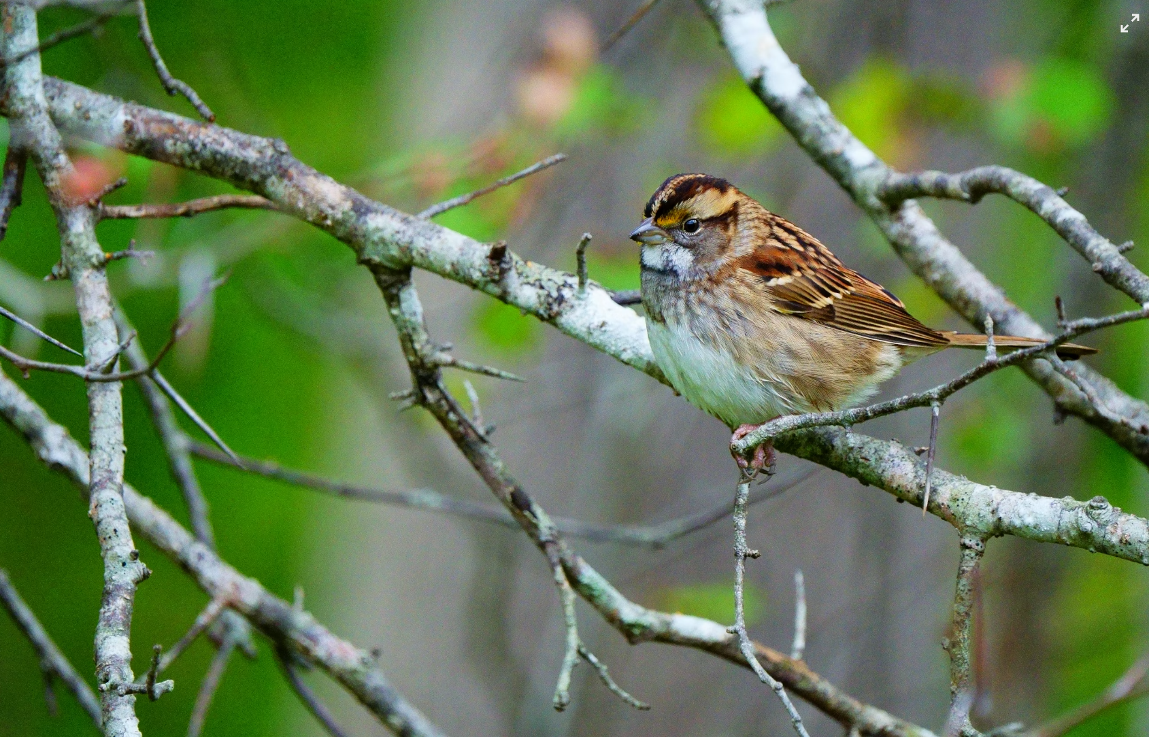 high-res images available, courtesy of Dietra Semple
"Maine's Quiet Beauty" invites you to notice what is easily missed. Each photograph reveals intricate details of what is native to Maine: the gentle bloom of vibrant flora, the silhouette of a bird in song, the otherworldly realm of fungi tucked away in the mossy forest. Dietra Semple’s photographs are her love letter to the seemingly small and unnoticed - a reminder that nature may unfurl quietly, but it speaks loudly in beauty.
About the photographer:
Dietra Semple is a self-taught photographer who is drawn to the beauty of creation. She is a native-born Texan who recently became a firmly planted Mainer. John Keats once wrote, "The poetry of the earth is ceasing never." Truer words were never spoken. In all its perfection, nature is already written flawlessly, and Dietra is but an observer seeking to capture the poetry within it.
_______________

Thursday, May 8 at 5 PM:
Maine Wonders with Zoe Weil
Event Page: https://ellsworth.libcal.com/calendar/EPL-Events/maine-wonders-with-zoe-weil
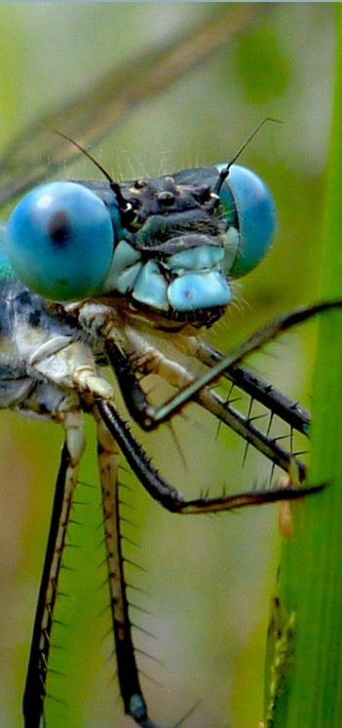 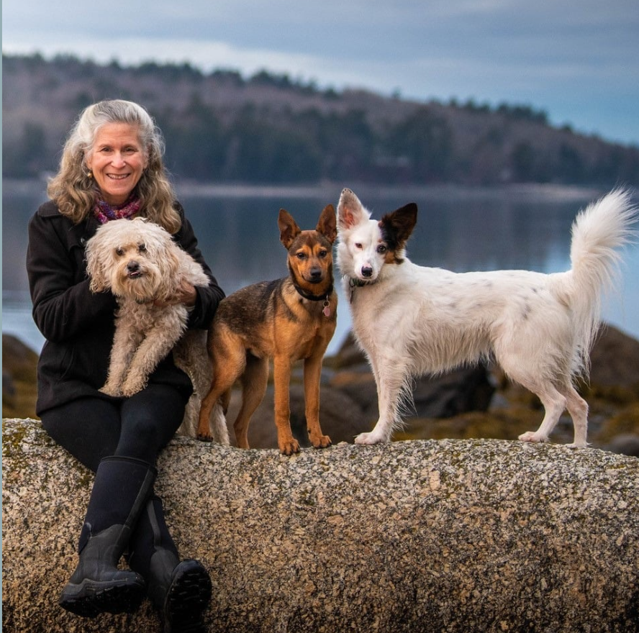 high-res available, courtesy of Zoe Weil
Maine Wonders invites you to step into the wild and curious corners of our natural world—where mind-boggling creatures thrive, fungi flourish, and transformation is a way of life. Along the way, you might just find your own sense of wonder awakened in ways that will astonish you.
This journey unfolds in four parts: Sex and Reproduction, Metamorphosis and Transformation, Iconic Maine Beauty, and The Weird and the Wild. From tide pools to vernal pools, deep forests to still lakes, you’ll meet the mammals, birds, amphibians, insects, and other life forms that make Maine a place of quiet astonishment. Come ready to learn, laugh, and leave with a deeper connection to the wild world right outside your door.
About Zoe Weil:
When she’s not writing and giving talks about becoming solutionaries through her work as the President of the Institute for Humane Education, Zoe is usually exploring nature with her three dogs, while photographing and videotaping Maine wonders. She has given six TEDx talks including her acclaimed TEDx, The World Becomes What You Teach.
She is the author of eight books, including her 2024 #1 Amazon new release in Social Philosophy, The Solutionary Way, Amazon #1 Best Seller in the Philosophy and Social Aspects of Education, The World Becomes What We Teach, and Nautilus silver medal winner Most Good, Least Harm. Zoe was named one of Maine Magazine‘s 50 independent leaders transforming their communities and the state and is the recipient of the Unity College “Women in Environmental Leadership” award. She was also a subject of Robert Shetterly's Americans Who Tell the Truth portrait series.
_______________
May – July 2025:
Forest Bathing with Shep Erhart
3 PM | Adults & Young Adults | Please register
Event Series
Monday, May 19
Monday, June 2, 2025
Monday, June 30, 2025
Monday, July 7, 2025
Monday, July 21, 2025
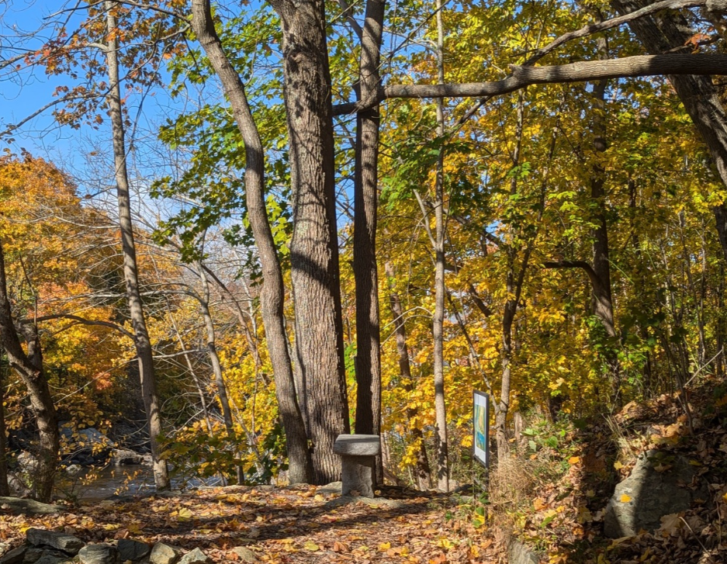 high-res image available | courtesy of EPL
Join Shep Erhart for a 1.5-hour stroll along the Union Riverwalk that begins with grounding exercises to help you connect with your body, breath, and sensations, calming your mind and reducing stress. This relaxing and restorative practice, rooted in traditional Japanese methods, is suitable for all ages and abilities. You’ll have the chance to explore your environment through touch, sight, sound, taste, and smell, with opportunities for sharing, silence, and a final herbal tea ceremony to build trust and community.
The group will meet in front of the upper entrance of the library. Registration for this event is required.
About Shep Erhart:
Shep Erhart is a certified Forest Therapy Guide. Shep and Linnette Erhart founded Maine Coast Sea Vegetables in 1971 in their farmhouse kitchen, inspired by a pot of miso soup that was especially delicious. They realized that the soups’ full, rich flavor came from the wild Alaria they had gathered from the shores of the Schoodic Peninsula, and they soon began sharing their Atlantic Wakame and other wild-harvested sea vegetables with friends and neighbors. At the time, few other folks were harvesting and selling seaweed in Maine, and within a few years, the Erharts built one of the most recognized and trusted brands in the industry.
Today, Maine Coast Sea Vegetables is an employee-owned company operating out of a modern processing plant in Hancock, Maine. Every year, their team of over twenty people sorts, packs, and ships several hundred thousand pounds of sea vegetables to customers all across the United States (& Canada). They pride themselves on being able to offer reliable and trustworthy information on the nutritional, health, culinary, and environmental benefits of North American sea vegetables.
_______________
NEW GROUP FOR ADULTS
Tuesday, May 6 at 10 AM:
The Friendship Group Kick-Off
First Meeting on May 6 at 10 AM | Monthly Group on the first Tuesday of the month at 10 AM
Event Page: https://ellsworth.libcal.com/calendar/EPL-Events/the-friendship-group
The Friendship Group is a monthly social group for adults with intellectual and developmental disabilities. Participants can enjoy games, relax, and connect with others. Light refreshments will be provided. During the first meeting, participants can contribute their ideas for activities.
The group will meet on the first Tuesday of each month at 10 AM upstairs in the Knitting Corner at the Ellsworth Public Library. The group will be run by EPL’s assistant director Renee Mcmanus.
______________

BOOK SALE AND BOOK LAUNCH FOR ALL AGES
May 15 – 17:
The Friends of the Ellsworth Public Library’s Spring Book Sale
Event Page: https://ellsworth.libcal.com/calendar/EPL-Events/spring-book-sale-2025-1
Thursday, May 15 from 1:30 PM to 5 PM
Friday, May 16 from 9 AM to 4 PM
Saturday, May 17 from 9 AM - 1 PM.
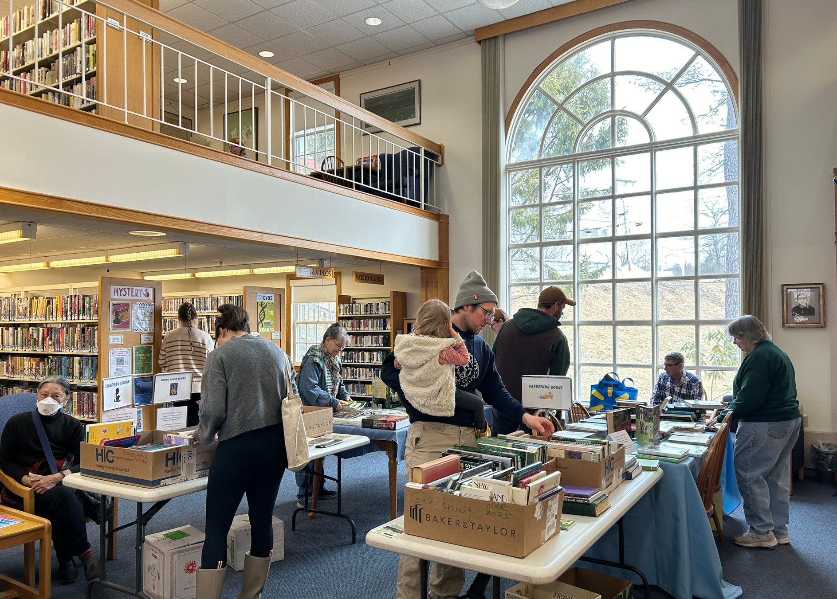 high-res image available
Stop at the Ellsworth Public Library for the Friends’ Spring Book Sale. Shop hundreds of gently used fiction and nonfiction books, books for kids and teens, DVDs, and puzzles! Book lovers will find books and more for all ages and interests—available by donation (cash or check only) unless otherwise marked. All proceeds directly support library programs, services, and special projects that benefit our whole community. To learn more about the Friends please visit the library’s website: https://www.ellsworthlibrary.net/friends-of-the-library/.
______________

Saturday, May 24 at 10 AM – 11 AM:
Book Launch: "Inside Out: Art and Writing by Residents of the Hancock County Jail"
Event Page: https://ellsworth.libcal.com/calendar/EPL-Events/book-launch-inside-out
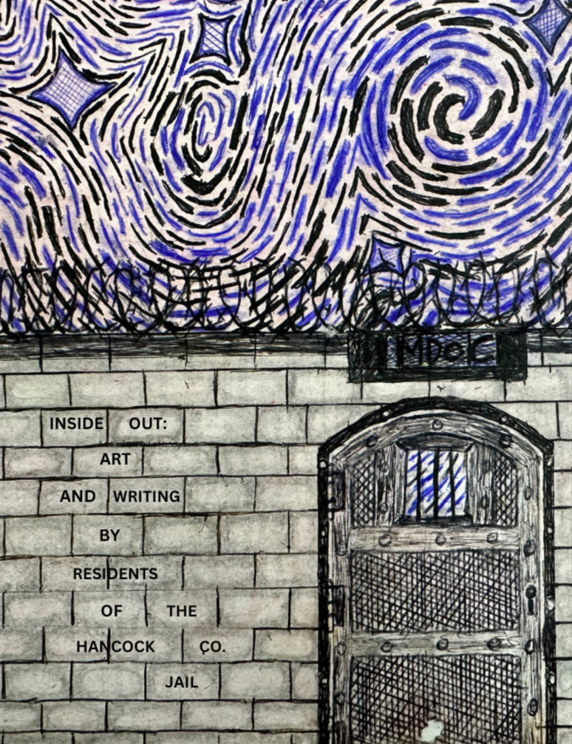 high-res image available
The public is invited to attend this book launch and reading of the recently released publication “Inside Out: Art and Writing by Residents of the Hancock County Jail” in the Riverview Room.
Over the course of the past 20 years, residents of the Hancock County Jail generated mixed media art pieces and creative writing in which they conveyed their thoughts, ideas, and insights in an evocative and engaging manner.
These inmates are our neighbors, family, friends, and community members. It is the purpose of this project to enlighten, encourage, and inspire members of the public with images and stories of growth, acceptance, and healing. The written and visual art created by the residents of the Hancock County Jail conveys the humanity of the artists and elicits feelings of empathy, hope, and understanding.
The Inside Out Anthology is a diverse collection of original artwork and writing by over 50 Hancock County Jail inmates, which will be distributed to correctional facilities, rehabilitation centers, and public libraries throughout the state. The intention is to educate the public about the effects of incarceration in an authentic, thoughtful, and impactful way.
Activities used to generate content for the Inside Out anthology can easily be duplicated by other programs/organizations; a list of resources will appear in the book’s appendix.
Former participants in the Inside Out project who attend the event will receive a complimentary copy of the publication and are encouraged to share their experiences and insights at the event.
_______________
KIDS & FAMILIES
Friday, May 9 at 2 PM:
Afterschool Pokemon Party
Event Page: https://ellsworth.libcal.com/calendar/EPL-Events/pokemon-party
Whether you're an experienced trainer, or just starting out on your journey, join Ms. Keli at the Ellsworth Public Library for a Pokemon Party on Friday, May 9 at 2 PM! There will be plenty of activities participants can pik-a-choose from including Pokemon-themed crafts, games, and a scavenger hunt to catch'em all!
_______________
Saturday, May 17 at 11 AM:
Mer-May! Storytime
Event Page: https://ellsworth.libcal.com/calendar/EPL-Events/mer-may-2025
Join Ms. Jean for a Mermaid-themed storytime down by the Union River!
The group will gather on the patio on the way to the riverwalk to read books and talk about the creatures who live in the sea and keep a lookout for a surprise guest! Wear something shimmery if you feel inspired - the event will end with a Mermaid Parade down the Ellsworth Riverwalk and back up to the library.
_______________
RESOURCES AND TRAININGS
Wednesday, May 7 at 1 PM:
Advancing Workforce for Mature Workers
Free Information Session on Job Training for Older Americans
Event Page: https://ellsworth.libcal.com/calendar/EPL-Events/job-training-for-mature-workers
The Senior Community Service Employment Program (SCSEP) is a community service and work-based job training program for older Americans. Authorized and funded by Title V of the Older Americans Act, the program provides training for low-income, unemployed seniors over the age of 55. SCSEP participants gain work experience in a variety of community service activities at 501(c)(3) non-profits and public facilities, including schools, hospitals, day-care centers, and senior centers. These agencies provide job skills training and help participants in their job search efforts. Participants train 20 hours per week while earning minimum wage.
About the Presenter:
Dawn Offerman is a Career Navigator and regional coordinator with Associates for Training and Development (A4TD) serving Penobscot, Piscataquis, Aroostook, Waldo, Knox, Washington, and Hancock counties. A4TD is a Senior Community Service Employment Program (SCSEP).
_______________
Saturday, May 17 at 1 PM:
Guide to Local Government hosted by the League of Women Voters of Maine
Event Page: https://ellsworth.libcal.com/calendar/EPL-Events/LWVME-presentation
The League of Women Voters of Maine (LWVME) encourages citizens to get more involved with local government. LWVME has prepared this Local Government educational session to inform residents of various ways that they can step into local government as well as participate in the long-term.
A nonpartisan presentation, this educational session will first review the very basics of how Maine communities govern themselves. Participants will gain a better understanding of chartered versus unchartered communities, how cities and counties are governed, how statewide representation is set up, and more.
About LWYME
The League of Women Voters of Maine is a nonpartisan political organization that encourages informed and active participation in government, works to increase understanding of major public policy issues, and influences public policy through education and advocacy. We never support or oppose any political party or candidate.
The League of Women Voters of Maine conducts action and advocacy as a nonprofit 501(c)(4) corporation. To learn more visit https://www.lwvme.org/
_______________
Saturday, May 31 at 12:30 PM:
Make a Difference – Volunteer Opportunities with Friends of Acadia
Info Table at the Library | Adults | Registration required
Event Page
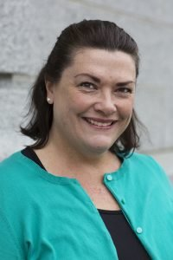 
courtesy of Friends of Acadia
Stop by the library to learn about volunteer opportunities with the Friends of Acadia (FOA). Volunteers play a key role in supporting FOA’s mission to preserve the natural beauty of Acadia National Park—and you could be part of that effort.
Find out what the role involves, how it connects to the community, and how you can get involved. Whether you’re a longtime park lover or just curious about volunteering, this is a great chance to explore how you can make a meaningful impact.
No registration is needed — just drop by and learn more!
Learn more about Volunteer opportunities here: https://friendsofacadia.org/get-involved/volunteer/
ALSO:
Thursday, June 5 at 4:30 PM:
Become a Membership Table Volunteer with Friends of Acadia
Presentation with JoAnne Wood from Friends of Acadia | Adults | Registration required
Event Page
Are you passionate about Acadia National Park and looking for a meaningful way to contribute? Join JoAnne Wood from Friends of Acadia for an engaging and informative session on how you can become a Membership Table Volunteer. Discover how easy and fun it is to support the park and connect with fellow Acadia enthusiasts.
Join us for an informative and inspiring talk with JoAnne Wood, Development Manager at Friends of Acadia, as she shares the important role that volunteers play at the FOA Membership Table. These volunteers are key to supporting the mission of preserving the natural beauty of Acadia National Park.
JoAnne will walk us through what this volunteer role involves, how it connects with the broader community, and what kind of impact you can make by getting involved. Whether you’ve volunteered before or are just starting to explore the idea, this session will give you a clear picture of how you can be part of something meaningful.
Come discover how you can lend a hand—and a heart—to help protect one of Maine’s most treasured places.
Apply to become a Membership Table Volunteer:
https://friendsofacadia.bamboohr.com/careers/50
An Ellsworth Public Library Card opens the door to a collection of more than 46,000 in-house items including books, large print books, audiobooks, movies, music CDs, and a growing Library of Things. Patrons have access to 50 print publications, streaming and download services. The New York Times is available to patrons on public access computers or any personal device. Additionally, patrons can request books through statewide Interlibrary loan services and reserve free passes to many renowned Down East museums. All library programs are free and open to all. Through a partnership with the Ellsworth American, anyone using the library’s Wi-Fi connection is granted free access to ellsworthamerican.com. www.ellsworthlibrary.net

