Tuesday, April 29, 2025
FOR IMMEDIATE RELEASE

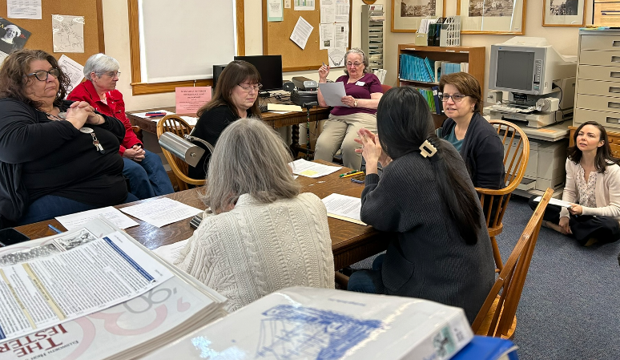
A Legacy in the Stacks:
One of Maine's Top Genealogy Collections Thrives in Ellsworth
Honoring Preservation Week 2025: April 27 – May 3, 2025: Preserve the Past, Shape the Future: Inspiring the Next Generation
Hands-on Genealogy Training for all library service staff led by Charlene Clemens, EPL’s Cataloger & Special Collections Manager | April 29, 2025
(press release and photos available for download on EPL’s website)
Ellsworth, Maine — “If you don’t know where you came from, you don’t know who you are.”
That belief has guided Charlene Clemens’ work since 1992, as she has built, expanded, and shared one of Maine’s most important genealogical collections. Clemens, the Cataloger and Special Collections Manager at the Ellsworth Public Library (EPL), is dedicated to ensuring that institutional knowledge is preserved and that researchers and curious residents continue to receive high-quality genealogy services. To support this goal, she led internal all-staff genealogy trainings in April.
“Genealogy is a very popular hobby. People want to know where they came from. When they read history, they’ll ask themselves, ‘Was my father in the war?’” Clemens explains. “We have Mayflower descendants researching their roots and many others exploring family connections to the American Revolution. And some discover relatives they never knew existed.”
EPL’s genealogy collection was made public in June 1993. It stands among the six most important in the state. Collection items include the Hancock County Genealogical Society Papers, rare monographs, privately donated family histories, and original records no longer published or widely available. These materials represent generations of lives, choices, and resilience and help tell the family histories of people in New England, Atlantic Canada, and other parts of the United States. Resources are available in print, on microform, and through digital databases, specifically, free onsite access to ancestry.com and www.americanancestors.org.
The Genealogy collection is available during regular library hours (Mon, Tue, Fri: 9 AM – 5 PM
Wed, Thu: 9 AM – 6 PM, Sat: 9 AM – 2 PM). It is also possible to send requests online via this page:
https://www.ellsworthlibrary.net/contact-us/
Genealogy page on EPL’s website: https://www.ellsworthlibrary.net/genealogy/
The page also includes a compilation of close to 30 online genealogy resources.
A Legacy of Genealogical Excellence
- On December 18, 2024, we were gifted an extraordinary resource to our genealogy collection. Sheldon Goldthwait of Bar Harbor has entrusted the Ellsworth Public Library with a genealogy database encompassing over 100,000 names. This comprehensive database focuses on Mount Desert Island families but also includes Hancock and surrounding counties.
Charlene Clemens Fox, who began curating the library’s genealogy collection in 1992, had been in conversations with Mr. Goldthwait for several years. “I’m very grateful Sheldon Goldthwait chose us as the home for his material,” Clemens said.
- In August 2005, the expanding collection was moved to the library’s dedicated Genealogy Balcony, where it continues to grow thanks to generous contributions and gifts.
- In May 2000, the New England Historic Genealogical Society in Boston named the Whitmore Collection one of the six most important genealogical resources in Maine (15 May 2000, Russell C. Farnham, C.G.).
- The Alvin S. Whitmore Memorial Collection for Genealogical Research at the Ellsworth Public Library, officially opened to the public on July 27, 1993. Named in honor of a beloved library trustee, the collection was established through a memorial fund from his family.
About Preservation Week 2025: Preserve the Past, Shape the Future: Inspiring the Next Generation (April 27 – May 3)
As a part of Core: Leadership, Infrastructure, Futures, Preservation Week inspires action to preserve personal, family, and community collections in addition to library, museum, and archive collections. It also raises awareness of the role libraries and other cultural institutions play in providing ongoing preservation education and information. The 2025 Preservation Week theme is Preserve the Past, Shape the Future: Inspiring the Next Generation. https://preservationweek.org/
An Ellsworth Public Library Card opens the door to a collection of more than 46,000 in-house items including books, large print books, audiobooks, movies, music CDs, and a growing Library of Things. Patrons have access to 50 print publications, streaming and download services. The New York Times is available to patrons on public access computers or any personal device. Additionally, patrons can request books through statewide Interlibrary loan services and reserve free passes to many renowned Down East museums. All library programs are free and open to all. Through a partnership with the Ellsworth American, anyone using the library’s Wi-Fi connection is granted free access to ellsworthamerican.com. www.ellsworthlibrary.net
Contact:
Berit Becker
Communications Director
Ellsworth Public Library
bbecker@ellsworthlibrary.net

